Research & Development Summary

1. Progress till Date
Our team has made significant strides in developing the foundational components of this project. Below is a detailed overview of our accomplishments:
- API Integration
  - Voice-to-Voice Functionality: We have successfully integrated APIs to enable real-time voice input and output, allowing for natural, conversational interactions. This feature forms the core of the system’s communication capabilities.
  - Informative Text Display: Alongside voice interaction, we’ve implemented a system to display relevant textual information, enhancing user understanding and engagement.
- Facial Animation
  - We’ve developed a preliminary facial animation system to provide visual feedback during interactions. This feature is customizable and can be adjusted or replaced based on your preferences or project requirements.

2. Current Limitations
While our progress is promising, certain constraints need to be addressed to ensure optimal performance:
- Dependence on Internet Connectivity: The system currently requires a stable and robust internet connection to function effectively, as it relies on cloud-based APIs for processing.
- Optional Text Display on Robot Body: If desired, we can adapt the system to project text directly onto the robot’s physical display. This would require additional hardware specifications from your end.
- I/O Port Compatibility: We are uncertain whether the input/output ports you are using are compatible with our APIs. Further details on your hardware setup will help us confirm integration feasibility.

3. Demo Creation
To showcase our work, we’ve developed a functional prototype:
- UI Prototype for Real-Time Conversation:
Prototype video drive url: https://drive.google.com/file/d/1x18zYTtI9PDsAFKhOb9-bEkznxlgCDTn/view?usp=sharing
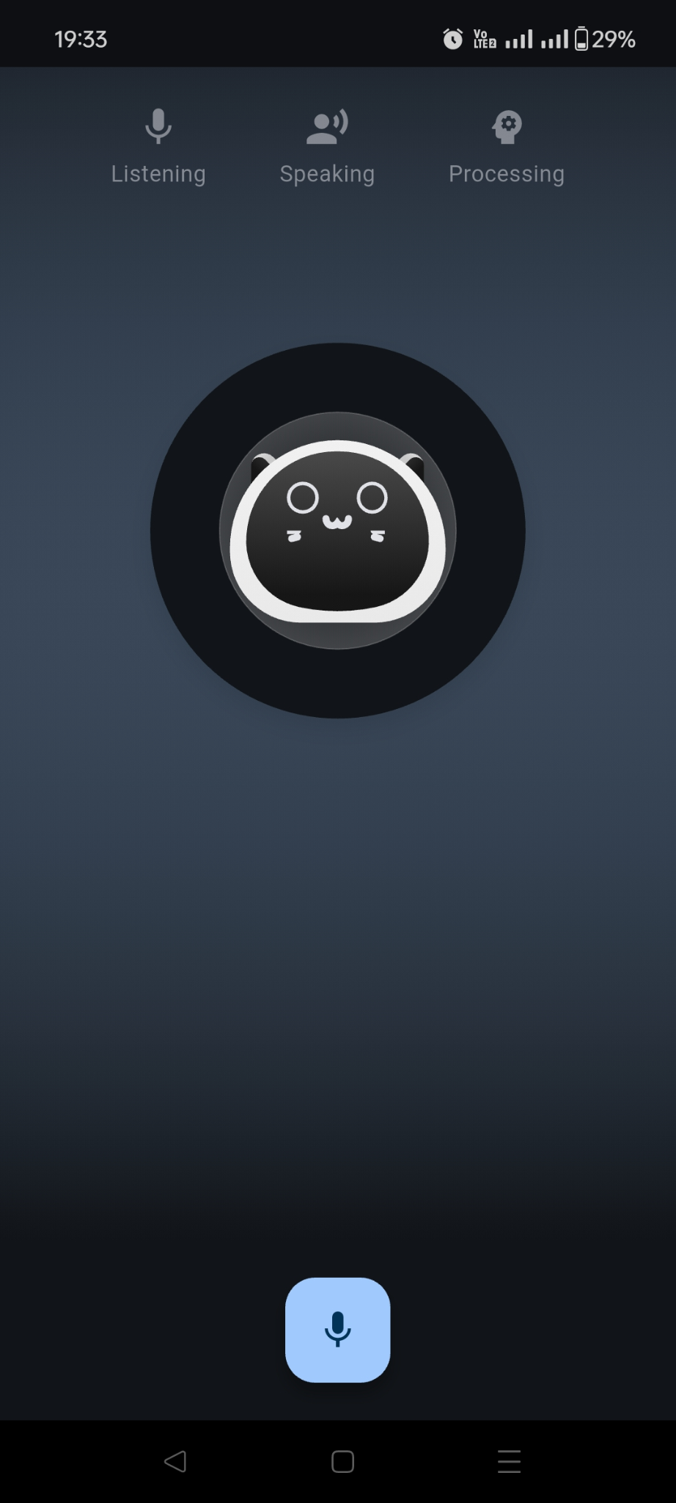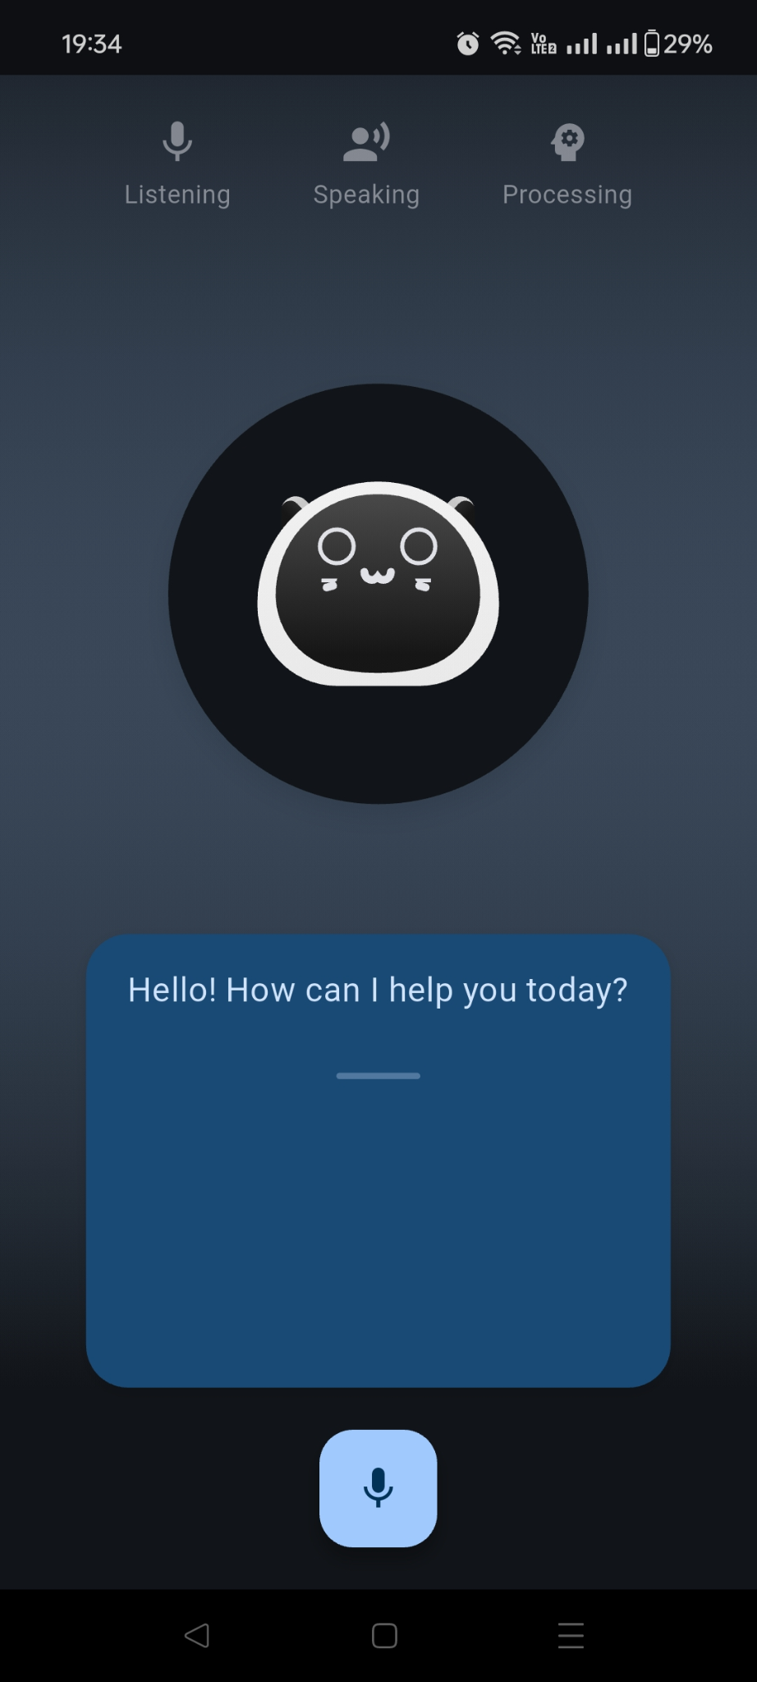

  - We created a user interface (UI) demonstrating the robot’s conversational abilities in real time. Due to the absence of a physical robot, this demo was built and tested on a mobile phone platform.
  - The prototype simulates the intended interaction flow and provides a proof-of-concept for stakeholders to evaluate.

4. Future Plans
Looking ahead, we have outlined key enhancements to elevate the project’s capabilities:
- Facial Expression Bot: We plan to refine the facial animation system into a fully expressive bot, capable of conveying emotions and improving user engagement.
- Robot Body Information Display: We aim to integrate a feature that displays system status or contextual information directly on the robot’s body, enhancing its interactivity.
- Movement Integration with Sensors: Our next step includes adding sensor-based movement controls (e.g., forward, backward, left, right), enabling the robot to navigate its environment autonomously or semi-autonomously.

5. Technical Details
Here’s an overview of the technical framework supporting our development:

Online Components
- APIs for Real-Time Processing:
  - We leverage industry-leading platforms such as OpenAI, Gemini AI, large language models (LLMs), and Grok AI (developed by xAI) to power the system’s intelligence and responsiveness.
- Custom Voice Solutions:
  - For voice synthesis, we utilize advanced tools like Deepgram and Eleven Labs to create natural, high-quality audio output tailored to the project’s needs.

Offline Suggestion
- Fallback for Network Loss: In case of connectivity issues, we propose integrating lightweight models from Hugging Face, such as GPT-2, LLAMA-3 to maintain system functionality. This offline solution, while effective for basic operations, may introduce performance lag due to processing limitations and relies on local memory caching to store model data and responses. To support this fallback mechanism, we recommend a hardware configuration with a minimum of 8GB RAM and 64GB ROM. This ensures sufficient memory for model execution and storage for cached data, enabling the robot to operate smoothly in offline scenarios without compromising core features.

6. Project Requirements
To proceed effectively, we require the following from your team:
- I/O Port Mapping: Detailed documentation of the robot’s input/output ports to confirm compatibility with our software and APIs.
- Full Circuit Diagram: A comprehensive design of the robot’s circuitry, enabling us to integrate movement controls and other hardware-dependent features seamlessly.

7. Open Questions
We seek clarification on the following points to align our efforts with your vision:
- Industry Clarification: What is the target industry or application for this robot (e.g., healthcare, education, customer service)? Currently, our approach is generalized, but a specific focus would improve efficiency and relevance.
- Operating System Preference: Which OS are you using for the robot? We recommend Linux for its flexibility and compatibility with our tools, but we need confirmation of your setup.
- OS Setup Status: Have you already configured the operating system? Please note that our team will not develop an OS; we assume it is pre-installed and ready for integration.

Conclusion
Our team has laid a solid foundation for this project, with functional prototypes and a clear roadmap for future enhancements. However, collaboration with your team is essential to address hardware specifications, resolve compatibility concerns, and refine the project’s direction. We look forward to your feedback and responses to our questions to ensure a successful outcome.

Update:
To create a versatile and highly functional robot, a well-rounded selection of technical equipment is essential. Here’s a detailed breakdown of the necessary technical equipment, their specific uses, and how they integrate within the system:

Technical Equipment and Their Uses
1. Microcontrollers/Processors (Raspberry Pi, Arduino)
- Use: Serve as the brain of the robot, processing data and controlling its actions.
- Integration: Interface with sensors, actuaries, and communication modules to execute high-level functions.
2. Sensors
- Cameras: Enable object recognition and visual navigation.
- Microphones: Capture voice commands for processing.
- Proximity Sensors: Detect obstacles to avoid collisions.
- Gyroscopes and Accelerometers: Track orientation and movement, crucial for balancing and navigating.
- Integration: Connect to the processor via GPIO pins or over I2C/SPI protocols, providing real-time data for processing and response.
3. Actuators (Servo and Stepper Motors)
- Use: Execute movements, from precise positioning (servo motors) to continuous rotation (stepper motors).
- Integration: Controlled by digital signals from the microcontroller, often using motor drivers to handle higher current loads.
4. Communication Modules (Wi-Fi and Bluetooth)
- Use: Enable network connectivity for remote control and data transfer; Bluetooth facilitates local device communications.
- Integration: Connect through USB or serial interfaces to the main processor, allowing the robot to receive commands and transmit data to other devices or the internet.
5. Storage (SD Card, RAM)
- Use: Store data logs, programming code, and temporary data for fast access (RAM).
- Integration: SD cards slot into the dedicated port on the processor, while RAM is typically integrated into the computing module.
6. Power Supply (Rechargeable Batteries, Power Management Module)
- Use: Provide and manage power to all components, ensuring safe operation and battery longevity.
- Integration: Batteries connect to the power management module, which distributes regulated voltages to the robot's components.

Software and Libraries
1. Operating Systems (Linux, RTOS)
- Use: Manage the software and hardware resources of the robot.
- Integration: Installed on the processor, acting as the platform for running all other software, including custom-developed programs and third-party libraries.
2. Programming Languages (Python, C/C++, JavaScript)
- Use: Develop the robot’s functionalities, from low-level hardware control (C/C++) to high-level AI and machine learning applications (Python).
- Integration: Code written in these languages runs on the operating system, interacting with hardware through device drivers and APIs.
3. AI and Machine Learning Libraries (TensorFlow, PyTorch, NLTK, spaCy)
- Use: Enable the robot to learn from data, recognize objects and process natural language.
- Integration: These libraries are implemented within the software applications, processing data collected by sensors and influencing the robot’s responses and actions.
4. Development Tools (IDEs like PyCharm, Version Control like Git)
- Use: Assist in the coding, testing, and maintenance of the robot’s software.
- Integration: Used during the development phase to write, test, and manage software versions, ensuring robustness and ease of updates.

Testing and Validation Tools
1. Simulation Software (Gazebo, MATLAB)
- Use: Simulate complex scenarios and algorithms without the need for physical testing, saving time and resources.
- Integration: Interfaces with the codebase to validate the functionality of the robot in a virtual environment before deployment in the real world.
2. Testing Frameworks (PyTest, GoogleTest)
- Use: Provide frameworks to ensure individual components and integrated systems work as intended.
- Integration: Run alongside the development environment, automatically testing the code as it is developed to catch errors early.
This comprehensive setup, from hardware assembly through software implementation to testing, ensures that each component of the robot is optimized for functionality and efficiency. The integration of these components allows the robot to perform complex tasks reliably, responding intelligently to its environment and user commands.

https://developer.amazon.com/en-US/docs/alexa/avs-device-sdk/raspberry-pi.html

https://developer.amazon.com/en-US/docs/alexa/ask-overviews/what-is-the-alexa-skills-kit.html

https://github.com/alexa/alexa-skills-kit-sdk-for-python
